Group Project 1

Develop insightful problems that can be used a as a specification so that it may be given to any developer to create queries to resolve to provide resolution to the problem. Also, it teaches the group how to investigate a new database system as if the business just acquired a new business. The IT department will be required to learn this new system for maintenance and enhancement purposes.

Learning how to work as a team and the concept that the team is more important than any individual. Exposure to working in a delegation model.

This assignment will leverage your understanding of Chapters 2, 3 and 6 as the basis for creating the queries

Contents

Project Tracking techniques documentation using Excel and Word 2

Each member of the group will develop 20 problem statements (propositions) and develop the solution. 3

At a minimum, there should be one queries from each of the 3 different databases below: 3

Problems should range from simple (5) to medium (8) to complex (7) 3

Group presentation 3

Identify the project leader for the group 3

Create PowerPoint Presentation which is voice annotated 3

The submission should include the following: 4

# Project Tracking techniques documentation using Excel and Word

1. Provide meeting notes (word document) with an agenda and attendance
2. Develop a to-do list for the team members using the To-do list. Each project in the worksheet will be the name of the group member and their responsibilities for the project and due dates.
3. Track the deliverables by original due date and revise due by with notes explaining the delay.

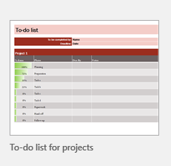

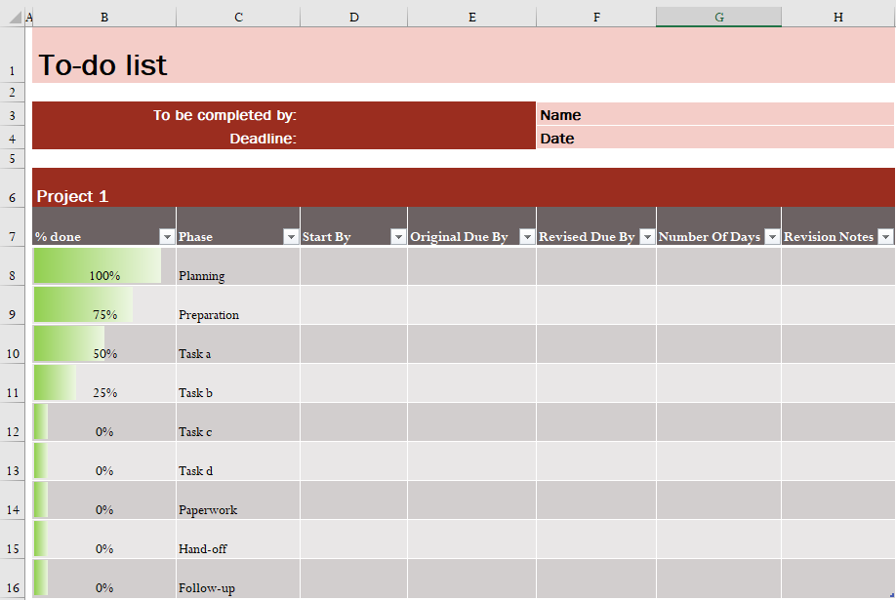

1. Use Gantt Project planner to track the summarized progress of the project. It will be managed by the project manager and shared with the group team[1]. The activity will be the individual tasks for each group member. Devise your own convention to include tracking delays.

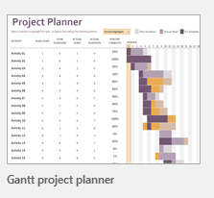

# Each member of the group will develop 20 problem statements (propositions) and develop the solution.

## At a minimum, there should be one queries from each of the 3 different databases below:

1. use AdventureWorks2014;
2. use AdventureWorksDW2014;
3. use Northwinds2019TSQLV5;

## Problems should range from simple (5) to medium (8) to complex (7)

**All queries must use the ANSI 92 standard for queries with the type safe “on”.**

1. Simple query should have up to 2 tables joined.
2. Medium query should have from 2 to 3 tables joined and use built-in SQL functions and group by summarization
3. Complex query should have from 3 or more tables joined, custom scalar function and use built-in SQL functions and group by summarization

# Group presentation

## Identify the project leader for the group

Who is the designated project leader for delegating work?

## Create PowerPoint Presentation which is voice annotated

The presentation should:

1. Identify the work of each of the individual members.
2. PowerPoint document should be named Class Time - Group Number – Group Project 1pptx
   1. Demonstrate the effectiveness of meetings with an agenda and attendance
   2. Show the to-do list
   3. Show the project plan
   4. Show each query noted by the Student Name and their Question Number
      1. Each query must be formatted using PoorSQL.com
      2. Have the proposition in the slide with the query.
      3. Leverage as much as you can from the template of your query submission.
   5. Summarize the team effort in the manner as you did by individual.
3. Each team member will review their problems by simple, medium and complex
   1. Prioritize their top 3 problems (simple, medium and complex); why they choose these problems for their top rating.
   2. Prioritize their 3 worst problems (simple, medium and complex); why they choose these problems for their lowest rating. How can the problems can be fixed to make it the best?
4. Review the team’s problems by simple, medium and complex
   1. Prioritize the Top problems from all of the members and why the team made the decision for the rating. Identify designed proposition and who wrought the query.
   2. Prioritize the worst problems from all of the members and why the team made the decision for the rating. Identify designed proposition and who wrought the query. How can the problem can be fixed to make it better by the team?
5. **If any of the members of the group do not participate, please notify me during the project period.**
6. Please keep the Class Time - Group Number – Group Project 1.mp4 from a range of 25 to 30 minutes (note: Each team member at a minimum needs must speak for 4 to 5 minutes explaining their work)
7. Please keep the Class Time - Group Number – JDBC Project 1.mp4 from a range of 10 to 15 minutes (note: Each team member must speak for 2 to 4 minutes explaining their work)

# The submission should include the following:

1. **Create a VHDX file as a submission format with a directory structure**. **Zip files or RAR files will not be accepted and marked late**.
2. Submit all of the project tracking techniques documentation
3. The individual group members problems should be submitted with the file name Group -Member Name using the template word document. **The query should be the code not a screenshot**.
4. Create a SQL file Group Number -Your Member Name.SQL with the problem statement and all 20 queries with use database Name and the individual query.
5. PowerPoint document should be named Class Time - Group Number – Group Project 1pptx
   1. Demonstrate the effectiveness of meetings with an agenda and attendance
   2. Show the to-do list
   3. Show the project plan
6. Create a voice annotated PowerPoint document should be named Class Time - Group Number – Group Project 1.mp4
7. Create a voice video of the JDBC execution of the group’s three top queries from simple, medium and complex execution. Nine queries in all, it should be named Class Time - Group Number – JDBC Project 1.mp4
   1. three top queries from simple, medium and complex execution
   2. three worst queries from simple, medium and complex execution
   3. three worst queries from simple, medium and complex execution that were corrected by the team to function as the three top queries.

1. See attached “Group Number – Gantt project 1 planner.xlsx”